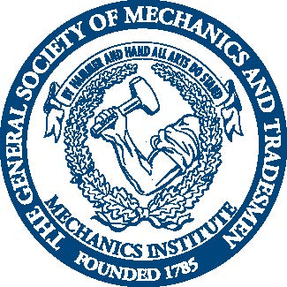

MECHANICS INSTITUTE
20 West 44th Street New York City, NY 10036

Construction Project Management
Required Essay

Please answer the following two questions with a combined total of approximately 350 words. All essays must be typewritten and submitted with all required documents to Admissions, by Friday, July 7, 2017. admissions@generalsociety.org

1) What motivated you to apply for enrollment in the Construction Project Management program at Mechanics Institute?

2) How will you benefit from the program in your career?

